Traps
- The father’s iniquities and the fathers’ iniquities (the difference)
- Our soul – what do we have stored in them?
- Dynamics of Oppression – How ground is yielded.
- Repentance
Prayer: Unconditional Surrender
Heavenly Father, I choose to totally commit my life to You. I choose to yield my will to You and to commit to Your will as You reveal it to me. I choose to yield all my rights to You. I choose to unconditionally surrender every part of my life – spirit, soul, and body – to anything You choose to do with it.
I recognize that my unconditional surrender cannot be taken back. Thank You for being committed to my commitment.
All this I pray in the name, the power, and the authority of the Lord Jesus Christ.
Amen
There is a difference between the father’s iniquities and the fathers’ iniquities. Your father’s iniquities include those iniquities in which your father has been involved. The fathers’ iniquities include the iniquities in which your father and his bloodline have been involved.
Exodus 20 says,
- The LORD your God, am a jealous God, visiting the iniquity of the fathers on the children, on the third and fourth generations of those that hate Me, but showing lovingkindness to thousands, to those who love Me and keep my commandments. (Exodus20:5-6)
We learn to survive and live in this world by watching the values and methods of our parents. We hear what they say and see how they respond to circumstances, and we store this information away until later when we need it.
These ways become strongholds (traps) for the enemy to utilize in your life. Even though we become born again, these fortresses remain intact. Until we tear them down by repentance and obedience, renewing our minds with the ways of God.
Let’s take a moment and pray, let’s ask God to show us our strongholds that must be confessed and broken.
1._________________________________________________________________
2.________________________________________________________________
3.________________________________________________________________
Prayers:
Confession of sin & Iniquities
Importance of the Soul:
Why is the Soul so crucial? Will your soul or spirit be the guiding force in your life? Within the soul, self resides so the question arises – what governs you? Given our gift of free will, will your soul take the reins, or will you invite the Holy Spirit to reside in your spirit? The soul encompasses the mind, emotions, and will, forming the core of our psychological self-consciousness. The soul is like a repository, where every life experience, from family, and childhood, to deepest fears and insecurities, is stored. Inferiority, insecurity, inadequacy, guilt, worry, doubts, fears, and frustration were all pieces of data carefully archived within.
Our experiences, weaknesses, and spiritual battles are stored within our souls. Failing to address these issues can have lasting effects, whether they be positive or negative. Engaging in spiritual warfare, as described in the Bible, is a means of closing these doors and gaining a divine perspective that allows us to discern the spiritual and earthly forces at play in our lives.
Let’s take a moment and pray, let’s ask God to show us what is stored in our souls that the devil can use as a trap against us.
1._________________________________________________________________
2.________________________________________________________________
3.________________________________________________________________
Prayers:
Knitting of Souls & Imprecatory Psalms & Confession of Sin

Dynamics of Oppression:
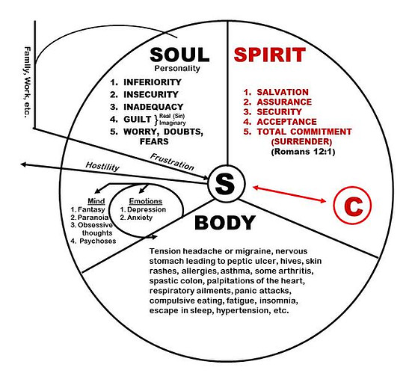
God’s predetermined plan for every believer is to conform us to the image of Christ. We must not deceive ourselves. God will not be slighted with disrespect. We will reap what we sow. He will use the very seeds of our disobedience, whatever form, or intensity it might take, to bring about His discipline in our lives.
- Do we seek God's desires for us or people’s desires? Are you leading the way God wants or people?
- Do you lead a spiritual life so that you can see with God's glasses (discernment) Are you walking with The Father, Son, and Holy Spirit? Do you invite the Holy Spirit into your heart, mind, and soul daily so that you can walk in the spiritual realm?
Prayer:
Renunciation and Affirmation

